Critical Infrastructure Protection EN.650.621 Fall 2025 Homework #2
Dave Ng’ang’a
Wed oct 14th 2026.

1. Using the security model in Figure 1, develop a defense-in-depth solution to protect the
fictitious network of a local electric utility company depicted in Figure 2 against the 4 types of
threats given the 3 types of adversaries and 3 types of exploitation points. Note, there is a guest
wifi network, a bring your own device (BYOD) wireless network, and an industrial control system
depicted in Figure 2. You can make any assumptions that you like, but please state them.

I am treating the two enterprise wireless networks as guest Wi-Fi and BYOD. Plants A, B, and C need some authorized communication with the enterprise, but that should not give every plant unrestricted access to the others. I assume conventional workstations can support endpoint security, while controllers may require vendor-approved monitoring and maintenance. My solution addresses confidentiality, integrity, availability, and theft, with external, internal, and supplier adversaries in mind.
Physical barriers: Initially, defense in depth has to start with physical barriers. I want badges, ID cards, gates, and appropriate PIN or biometric checks so that physical access is limited to the people who need it. Security guards, cameras, visitor escorts, and equipment checks should cover people and equipment coming in and out. The mainframe, server rooms, maintenance systems, and controllers need particular protection. This helps against both unauthorized entry and theft by someone who already has access to the site.
Firewalls and segmentation: I noticed that the routers are at the point of connection for each plant, so I want firewall enforcement at those boundaries as well as the control-system firewalls already shown. Plants A, B, and C should have separate security zones, with only required traffic allowed between them and the enterprise. Within each plant, workstations and business servers should be separated from control-system servers and controllers. Opening one door into the network should not let someone see every plant. Internal traffic still needs verification; being inside does not automatically make it trustworthy.
The guest Wi-Fi network should not be able to see anything in the plant at all. BYOD should also be treated as untrusted, with access only to explicitly approved business services and no direct ICS access. I would use client isolation where appropriate and network admission controls for wired connections too. Plugging in a cable should not give someone access to everything. A new MAC address can raise an alert, but device identity and authorization need stronger checks than the MAC address alone.
Least privilege and remote access: People should get only the access they need, only for as long as they need it. This is especially important for internal and supplier adversaries. Administrative accounts should be separate from ordinary accounts, heavily secured, and used only when required. Service accounts should be limited to their own services. Strong passwords, phishing-resistant MFA, approval of privileged access, and session logging would support this. Any necessary remote support should use an approved, managed device and an authenticated gateway or VPN, followed by a controlled jump host. There should be no direct public access to controllers. A public information website, if needed, belongs in a separate zone.
Endpoint and application protection: I want host firewalls, EDR, application allowlisting, and removable-media controls on supported workstations and servers. Email filtering and phishing awareness would reduce credential and malware delivery risks. A web application firewall belongs in front of HTTP/HTTPS applications and file/print and other non-web services need controls appropriate to their protocols. Device management can enforce configuration and collect logs on compatible endpoints, but I would not assume that ordinary MDM or EDR can run on every controller.
Patching and suppliers: I want a good patch-management process and software lifecycle for outdated workstations, servers, and network devices. ICS patches need compatibility testing and planned maintenance rather than instant deployment that could interrupt the plant. Supplier software and firmware should be obtained through approved channels and checked for authenticity before deployment. Vendor access should be temporary, logged, and revoked afterward. This covers remote access, system administration and normal usage, and supply-chain exploitation rather than relying on one perimeter defense.
Encryption, monitoring, and theft prevention: Credentials and sensitive data should be encrypted in transit and at rest. Where legacy control protocols cannot support this directly, I would protect their communication paths with segmentation and suitable secure gateways. Encryption does not stop someone using an account already authorized to read the data, so access restrictions and monitoring still matter. I want a blue team collecting endpoint, identity, firewall, server, and supported control-system logs. Unusual account use, changes to configurations or startup settings, unexpected outgoing connections, and large unauthorized file transfers should prompt investigation. Outbound restrictions and data-loss controls would help limit exfiltration.
Backups and response: Because this is an ICS, I especially want configuration backups for controllers and management software, along with protected off-site and offline or immutable copies. Restoration needs to be tested. Redundant services and controllers, where supported, would reduce downtime. The blue team should be able to isolate a compromised device or disconnect a plant from other networks through a procedure coordinated with operators, so containment does not itself create unsafe conditions.
Together, least privilege and encryption protect confidentiality; approved changes, software verification, and configuration monitoring protect integrity; segmentation, redundancy, and tested recovery protect availability; and physical security, access auditing, and outbound controls address theft. These defense in depth layers give us more than one opportunity to stop or contain an external attacker, a malicious insider, or a compromised supplier.

2. Develop a hacker’s cyber-attack strategy on the network in Figure 2 similar to the cyber-attack
strategy described on Pages 64-65 in Richard Clarke’s Cyber War. Identify at least 10 attacks and
make sure your defense-in-depth solution in #1 contains all of the necessary defenses to avert
or mitigate the risks associated with the identified attacks. Assume that the adversaries want to
release advanced persistent threat (APT) into the network to compromise the industrial control
systems and to maintain a presence in the network. Note, familiarize yourself with the life-cycle
of APT.

Approaching the attack strategy through the three areas in Clarke’s Defensive Triad: the Internet backbone, the power grid, and end-user protection. For this utility, I am applying those areas to its external and enterprise connections, the control systems at Plants A, B, and C, and the employees and devices that access those networks.
The attacker’s objective is to establish advanced threat persistent access and eventually compromise the industrial control systems. The attacks below represent possible routes toward that objective.
Harden the Internet backbone
At the utility level, I would focus on the connections between external networks, the enterprise, and the plants.
- Exploit an exposed service. An attacker could attempt to compromise an outdated application or remote-access service to establish an initial foothold. Patch management, restricted management interfaces, and protocol-appropriate firewall rules would help mitigate this risk.
- Abuse supplier remote access. A compromised supplier account could provide access through a connection intended for maintenance. However, suppliers should get only the access they need, only for as long as they need it. MFA, approved devices, monitored sessions, and controlled jump-host access would limit this route.
- Establish unauthorized command-and-control communications. After compromising a device, the attacker could attempt to communicate externally through traffic that appears legitimate. Ideally though outbound filtering and network monitoring should be combined with endpoint and identity logs so the blue team can investigate which process and account initiated the connection. Encryption alone would not establish that the traffic is safe.
- Exfiltrate files or configuration information. The attacker could collect information and send it through an allowed connection. However, If someone is archiving a lot of files and appears about to ship them out, that should flag the blue team. Least privilege, data-loss controls, and transfer monitoring would help limit this activity.
Secure the power grid
The next concern is whether an initial compromise can reach the plant control systems. It should not be the case that opening one door gives someone access to every plant.
- Move from enterprise systems into a plant. An attacker could misuse an account or permitted connection to reach plant resources.
Separate security zones and tightly restricted communication between the enterprise and each plant would limit that movement.
- Move between plants. Access to Plant A could become a pivot point for attempts against Plants B and C or the mainframe.
Each plant should have independently enforced access restrictions rather than relying on the assumption that traffic from another plant is trustworthy. This should be enforceable through the firewall verifying the source of incoming packets
- Compromise a maintenance or administrative account. An attacker could seek access to the systems used to manage controllers. However, administrative/service accounts should be separate, heavily secured, and used only when required. Approved maintenance paths, MFA where supported, least privilege, and session logging would make this access harder to obtain and misuse.
- Modify control-system configurations or commands. The attacker could use unauthorized administrative access to change how the plant operates. In an ICS, the files might be helpful, but what is more damaging is the access. Ideally, authenticated control communications, approved changes, configuration monitoring, and restricted controller access would address this threat. Tested configuration backups and operator-coordinated recovery would help restore operations if prevention failed.
Protect end users
Employees, contractors, and their devices provide additional opportunities to enter the network or maintain access.
- Spear-phish an employee. Stolen credentials could allow an attacker to act through an apparently legitimate account.
Email controls, awareness, phishing-resistant MFA, and least privilege would reduce the likelihood and impact of compromise.
- Introduce an infected BYOD device. A personal device could bring malware into the environment. Though, BYOD should be treated as untrusted, with no direct access to the ICS. Device admission checks, segmentation, and client isolation would limit its reach.
- Deliver malware through removable media. An employee could plug an infected flash drive into a workstation. However, removable-media restrictions, approved transfer procedures, application allowlisting, and EDR would provide several defensive layers.
- Establish persistence on a compromised endpoint. An attacker could create unauthorized startup changes or misuse legitimate administrative tools to maintain access.
EDR, account reviews, configuration baselines, and correlated logging would help identify that activity. The blue team should be able to isolate an affected endpoint without assuming that antivirus or a firewall will detect every threat.
A plausible campaign would begin with reconnaissance and an employee or supplier compromise, then attempt to establish communications, broaden access, and reach plant administration. Persistent access could allow the attacker to return over time rather than immediately disrupting operations. Clarke’s triad gives the defense three connected areas of responsibility: controlling network communications, protecting the control systems, and securing the users and devices that might otherwise provide a route between them.

4. Goto http://www.shodanhq.com/ (an online resource to expose devices that are connected to
the internet, but probably should not be) and identify devices with weak authentication and also
devices with strong authentication. Prove that you have found the proper devices, see [1] for a
hint (Section VI-A), which is a published Capstone project by one of my former students. Please
note, I am NOT GIVING YOU PERMISSION to attack or login to any network on Shodan.
I used existing Shodan records to compare a MongoDB service that disclosed operational information with a PostgreSQL service that rejected a connection. I did not connect to either host or attempt to log in. The evidence supports a comparison of observed access controls, but it does not establish the strength of passwords or every permission on either system.
Weak-access-control example: MongoDB, France
The French host, 164.132.244.137, has a MongoDB service on TCP port 27017. Shodan’s captured response shows “MongoDB Server Information” followed by detailed operational metrics and command counters. This is more informative than a version banner and is consistent with insufficient restrictions on server-status information.
My search was: “MongoDB server information” port:27017 -authentication. Showing that information is being returned on a port that is supposed to be behind authentication.
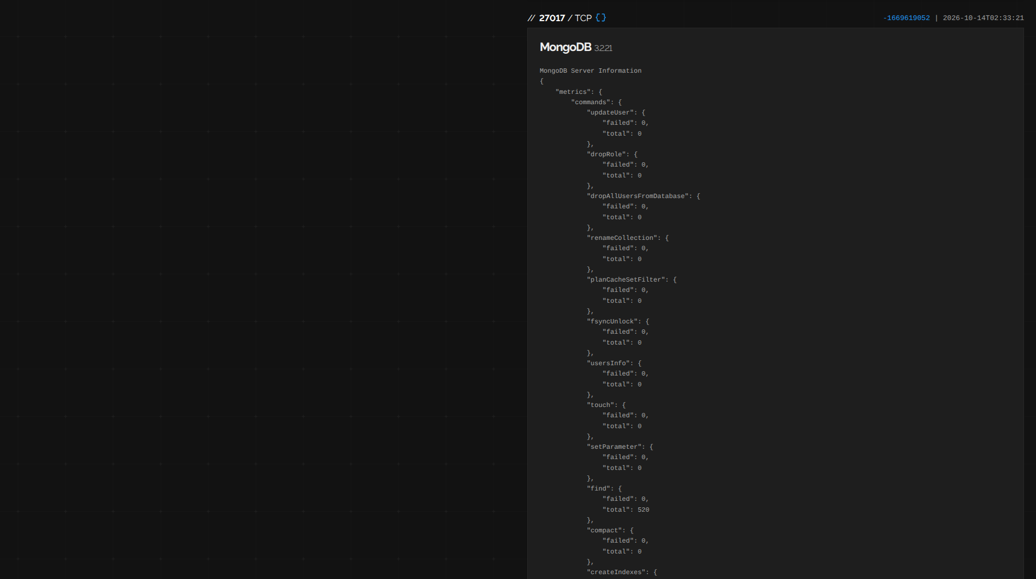
Figure 1. Shodan’s recorded MongoDB response on port 27017 exposes operational metrics. The host identity and French location were established in the accompanying host overview reviewed during the investigation. Banner timestamp shown: October 14, 2026, 02:33:21.
Restricted-access comparison: PostgreSQL, Germany
The German host, 158.220.103.240, has a PostgreSQL service on TCP port 5432. Its recorded response says “FATAL: no pg_hba.conf entry” for the attempted connection and identifies the user as “postgres,” the database as “template0,” and the connection as having “no encryption.” This shows that the particular connection was rejected because no matching access rule permitted it (PostgreSQL Global Development Group, n.d.).
This is a stronger observed access boundary than the MongoDB information disclosure. This example demonstrates enforced connection restrictions, which we can use to assume stronger authentication compared with the first example.
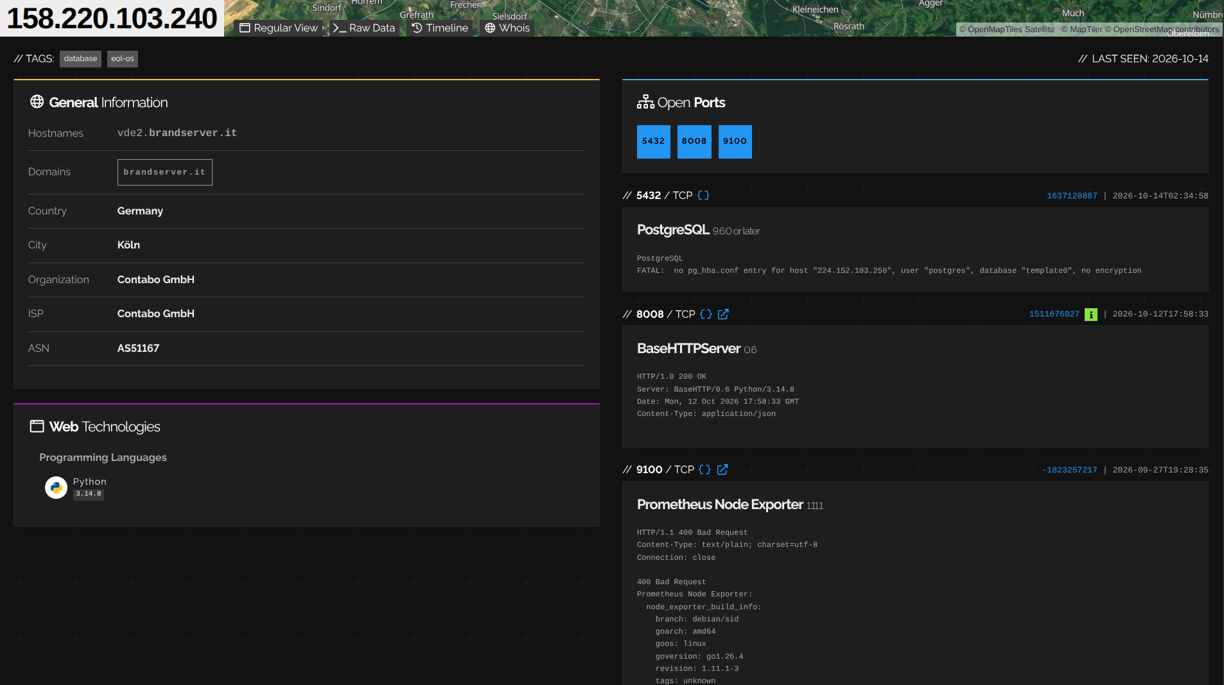
Figure 2. Shodan’s PostgreSQL record shows a rejected connection on port 5432. The host overview identifies Germany. Database-banner timestamp shown: October 14, 2026, 02:34:58.
References for Question 4
Shodan. (n.d.). Host records for 164.132.244.137 and 158.220.103.240 [Screenshots of indexed service responses]. https://www.shodan.io/host/164.132.244.137 ; https://www.shodan.io/host/158.220.103.240
Shodan. (n.d.). Search query fundamentals. https://help.shodan.io/the-basics/search-query-fundamentals
MongoDB. (n.d.). serverStatus (database command). https://www.mongodb.com/docs/manual/reference/command/serverstatus/
PostgreSQL Global Development Group. (n.d.). Authentication problems. https://www.postgresql.org/docs/17/client-authentication-problems.html

5. Concerning the ICS malware you designed in #2, provide details steps and practical tools for
static and dynamic analysis and forensics of this malware. In other words, assuming you capture
artifacts from this malware, how would you most effectively study them?

Such a malware would be obfuscated, use tools native to the operating system, and communicate through traffic that resembles ordinary web activity. This also assumes the malware is moving through windows systems. Similar tactics would be employed for other operating systems
1. Preserve the evidence. Before changing the affected system, I would record where the artifact came from, when it was collected, and who handled it. I would calculate a SHA-256 hash, preserve the original, and analyze a working copy. I would collect relevant endpoint, login, firewall, and maintenance logs, plus a disk image and volatile memory where safe and technically supported. On a live plant system, collection and containment would be coordinated with operators rather than risking an outage just to obtain evidence.
2. Establish an isolated analysis environment. I would study copies in a disposable laboratory system with snapshots, no production credentials, and no route to the utility's real network or controllers. Where network interaction is needed, I would simulate services inside the lab. Controller-specific behavior would require a representative test environment.
3. Perform static analysis. I would first inspect the artifact without executing it: its actual file type, hashes, readable strings, metadata, and any digital signature. Tools such as file, strings, and Microsoft's Sigcheck can support this first pass. I would look for addresses, paths, imported functions, or configuration material, then use Ghidra to examine relevant code and control flow. Obfuscation could make this difficult.[1, 2]
4. Observe execution and persistence. In the isolated lab, I would compare the system before and after execution. Process Monitor would help capture file, Registry, and process activity, while Process Explorer would help identify parent-child relationships and the processes involved. Autoruns would help check changes to supported Windows startup locations. I would examine unexpected configuration changes, dropped files, account activity, and attempts to keep running after a restart. A quiet run is not proof of safety: the sample may depend on a trigger or an environment that the lab does not reproduce. [3, 4, 5]
5. Examine network behavior. Dynamic analysis would help connect the suspected process to its communications. I would use Wireshark alongside endpoint connection records to compare destinations, timing, volume, and connection patterns. Even if the content is encrypted, those observations can still raise questions. Suspicious network activity needs to be correlated with the process and account that produced it. [6]
6. Analyze memory and build a timeline. I would use the open-source Volatility 3 on a supported memory image to examine process and memory artifacts relevant to the suspected malware. I would correlate the findings with disk artifacts, authentication records, startup changes, and network events. For the ICS side, I would compare recovered controller or maintenance configurations with trusted backups and approved change records. [7]
7. Investigate the actual objective. If the evidence suggests theft, I would look for unauthorized collection, staging, and transfers. If it suggests ransomware or disruption, I would look for widespread file changes, service interruption, or unauthorized configuration changes. In my initial thinking, unusual disk activity stood out; I would investigate that behavior.
8. Turn the findings into a response. I would document the hashes, paths, persistence mechanisms, network observations, and affected accounts or systems that the evidence supports. I would distinguish confirmed behavior from assumptions, preserve the investigation record, and give the blue team findings it can use to search for related activity. Recovery would include removing unauthorized access, rotating affected credentials, restoring trusted configurations, and checking that the original entry route is closed before reconnecting systems.
References for Question 5
[1] Microsoft. Sigcheck. https://learn.microsoft.com/en-us/sysinternals/downloads/sigcheck
[2] National Security Agency. Ghidra. https://github.com/NationalSecurityAgency/ghidra
[3] Microsoft. Process Monitor. https://learn.microsoft.com/en-us/sysinternals/downloads/procmon
[4] Microsoft. Process Explorer. https://learn.microsoft.com/en-us/sysinternals/downloads/process-explorer
[5] Microsoft. Autoruns. https://learn.microsoft.com/en-us/sysinternals/downloads/autoruns
[6] Wireshark Foundation. Documentation. https://www.wireshark.org/docs/
[7] Volatility Foundation. Volatility 3. https://github.com/volatilityfoundation/volatility3

